SYDNEY WESTERN CITY PLANNING PANEL

Panel Number: | 2016SYW161
Application Number: | 866/2016
Local Government Area: | Camden.
Development: | Tree removal, construction of a mixed use development consisting of five (5) buildings comprising residential flat buildings and shop top housing for a total of 436 apartments, one (1) neighbourhood shop, basement car parking, road construction, subdivision and associated site works.
Capital Investment Value: | $141,666,455
Site Address(es): | 202 Byron Road, Leppington
Applicant: | NLI Byron Development Pty Ltd
Owner(s): | Leppington Gateway Pty Ltd
Date of Lodgement: | 29th July 2016
Number of Submissions: | Three (3) submissions were received.
Classification: | Nominated Integrated and Integrated development.
Recommendation: | Deferred commencement.
Regional Development Criteria (Schedule 7 of State Environmental Planning Policy (State and Regional Development) 2011): | General development capital investment value >$30 million.
List of All Relevant Section 4.15(1)(a) Matters: | • State Environmental Planning Policy (State and Regional Development) 2011  • State Environmental Planning Policy (Sydney Region Growth Centres) 2006  • State Environmental Planning Policy No 55 – Remediation of Land  • State Environmental Planning Policy No 65 – Design Quality of Residential Apartment Development  • State Environmental Planning Policy (Building Sustainability Index: BASIX) 2004  • State Environmental Planning Policy (Infrastructure) 2007  • Sydney Regional Environmental Plan Policy No 20 – Hawkesbury-Nepean River  • Camden Development Control Plan 2011  • Camden Growth Centre Precincts Development Control Plan  • Apartment Design Guide
List all Documents Submitted with this Report for the Panel’s Consideration: | - Assessment report.  - Applicant’s clause 4.6 written request seeking to justify the contravention of a development standard.  - State Environmental Planning Policy (Sydney Region Growth Centres) 2006 assessment table.  - Apartment Design Guide Assessment Table  - Camden Growth Centre Precincts Development Control Plan Assessment Table.  - Recommended conditions.  - Proposed plans.  - Submissions.
Development Standard Contravention Request(s): | Clause 4.3 - Maximum height of buildings  State Environmental Planning Policy (Sydney Region Growth Centres) 2006.
Summary of Key Submission Issues: | - Open space treatment  - Stormwater / stormwater retention  - On-site carparking  - Flooding  - Impact on health and wellbeing of local residents  - Environmental impact and sustainability  - Existing traffic, noise and parking problems already on Byron Road, Leppington  - Hardship from acquisition  - Provision for access across the proposed rear boundary open space linkage
Report Prepared By: | Adam Sampson, Executive Planner
Report Date: | 3 August 2020.

Summary of Section 4.15 Matters

Yes
Have all recommendations in relation to relevant Section 4.15 matters been summarised in the Executive Summary of the assessment report?

Legislative Clauses Requiring Consent Authority Satisfaction

Yes
Have relevant clauses in all applicable environmental planning instruments where the consent authority must be satisfied about a particular matter been listed and relevant recommendations summarised in the Executive Summary of the assessment report?

Development Standard Contraventions

 | Yes | N/A
If a written request for a contravention to a development standard has been received, has it been attached to the assessment report?

Special Infrastructure Contributions
 | Yes | No
Does the application require Special Infrastructure Contributions?

Conditions

Yes
Have draft conditions been provided to the applicant for comment?

PURPOSE OF REPORT

The purpose of this report is to seek the Sydney Western City Planning Panel’s (the Panel’s) determination of a development application (DA) for tree removal, construction of a mixed use development consisting of five (5) buildings comprising residential flat buildings and shop top housing for a total of 436 apartments, one (1) neighbourhood shop, basement car parking, road construction, subdivision and associated site works at 202 Byron Road, Leppington.

The Panel is the determining authority for this DA as, pursuant to Schedule 7 of State Environmental Planning Policy (State and Regional Development) 2011, the capital investment value (CIV) of the proposed development is $141,666,455, which exceeds the CIV threshold of $30 million for Council to determine the DA.

SUMMARY OF RECOMMENDATION

That the Panel determine DA/866/2016 for tree removal, construction of a mixed use development consisting of five (5) buildings comprising residential flat buildings and shop top housing for a total of 436 apartments and one (1) neighbourhood shop pursuant to Section 4.16 of the Environmental Planning and Assessment Act, 1979 by granting deferred commencement consent subject to the conditions attached to this report.

EXECUTIVE SUMMARY

Council is in receipt of a DA for tree removal, construction of a mixed use development consisting of five (5) buildings comprising residential flat buildings and shop top housing for a total of 436 apartments, one (1) neighbourhood shop, basement car parking, road construction, subdivision and associated site works at 202 Byron Road, Leppington.

The DA has been assessed against the Environmental Planning and Assessment Act 1979, the Environmental Planning and Assessment Regulation 2000, relevant environmental planning instruments, development control plans and policies.

A summary of the assessment of all relevant environmental planning instruments is provided below with a detailed assessment provided later in the report.

State Environmental Planning Policy (State and Regional Development) 2011. | The Panel is the consent authority for this DA as the development has a CIV of $141,666,455, million which exceeds the CIV threshold of $30 million for Council to determine the DA.
State Environmental Planning Policy (Sydney Region Growth Centres) 2006 (Growth SEPP). | The development is permitted with consent in the applicable SP2 Infrastructure and R3 Medium Density Residential zones and is consistent with the zones’ objectives and acceptable in terms of the Growth SEPP’s other matters for consideration.
State Environmental Planning Policy No 55 - Remediation of Land. | Council staff have assessed a detailed contamination assessment and associated information submitted in support of the DA. Following submission of the detailed contamination assessment Council staff were satisfied that the site was suitable for the development.  Following this detailed contamination assessment, a large quantity of asbestos was illegally dumped upon the site in February 2019. As this material sits on top of the soil and not buried within the soil, conditions of consent have been prepared requiring that the dumped material is tested, removed from site and any remaining soil validated to ensure that the material has been appropriately removed.
State Environmental Planning Policy No 65 – Design Quality of Residential Apartment Development | The development is largely consistent with the Design Quality Principles and the Apartment Design Guide.
State Environmental Planning Policy (Building Sustainability Index: BASIX) 2004 | The applicant has submitted a valid BASIX certificate in support of the DA that demonstrates that water, thermal comfort and energy requirements have been achieved.
State Environmental Planning Policy (Infrastructure) 2007 (ISEPP). | The DA was referred to RMS and Sydney Trains pursuant to the ISEPP and comments and recommended conditions received have been considered.
Sydney Regional Environmental Plan No 20 - Hawkesbury-Nepean River (SREP 20). | The development is consistent with the aim of SREP 20 (to protect the environment of the Hawkesbury-Nepean River system) and all of its planning controls.

The DA was publicly exhibited for a period of 30 days in accordance with Camden Development Control Plan 2011. The exhibition period was from 10 August to 8 September 2016. Two submissions were received (one objecting to the development and one raising a matter for consideration).

Following the submission of amended plans and additional information the DA was publicly re-exhibited for a period of 30 days in accordance with Camden Development Control Plan 2011. The re-exhibition period was from 21 February to 22 March 2018. Two submissions was received.

The issues raised in the submissions relate to:

• Open space treatment

• Stormwater / stormwater retention

• On-site carparking

• Flooding

• Impact on health and wellbeing of local residents

• Environmental impact and sustainability

• Existing traffic, noise and parking problems already on Byron Road, Leppington

• Hardship from acquisition

• Provision for access across the proposed rear boundary open space linkage

The DA has been assessed against the Environmental Planning and Assessment Act 1979, the Environmental Planning and Assessment Regulation 2000, relevant Environmental Planning Instruments, Development Control Plans and policies.

The applicant proposes a contravention to the height of buildings development standard that applies to the site. The development standard limits buildings to a maximum height of 21m above finished ground level. However, the development will have a maximum height of 21.25m above finished ground level, measured to the top of a lift overrun atop Building E. A height breach to another lift overrun atop Building D (21.07m) is also proposed. The proposed height contraventions will not result in any perceptible visual impacts due to the lift overrun locations being centrally atop buildings D and E and will not result in additional overshadowing upon the public domain or communal open space areas. The contravention is assessed in detail in this report and is supported by Council staff.

In addition, the applicant proposes variations to primary and secondary setbacks (corner lots) contrary to the development controls of Table 4-10 Clause 4.3.5(3) of Camden Growth Centre Precincts Development Control Plan. Variation to these setbacks assists in modulating and providing horizontal and vertical articulation to the facades, which would otherwise result in a uniform setback across multiple facades as per the development controls. The variation is assessed in further detail in this report and is supported by Council staff.

Based on the assessment, it is recommended that the DA be granted deferred commencement consent subject to the terms and conditions attached to this report.

KEY PLANNING CONTROL VARIATIONS

Control | Proposed | Variation
21m maximum building height. | 21.25m maximum building height. | 250mm
Front setback – 6m. Balconies and other articulation may encroach into the setback to a maximum of 4.5m from the boundary for the first 3 storeys and for a maximum of 50% of the façade length.  Secondary setback – 6m | Front setback – 4.5m to articulated elements upon the 2nd, 3rd and 4th floors (4th, 5th and 6th storeys) facing Byron Road.  Secondary setback – 4.5m to Building C – Town Centre Road (North), 4.5m to Buildings C and E – Collector Road (East) and Buildings D and E to Local Residential Street (South). | Front setback – 1.5m  Secondary setback – 1.5m

AERIAL PHOTO

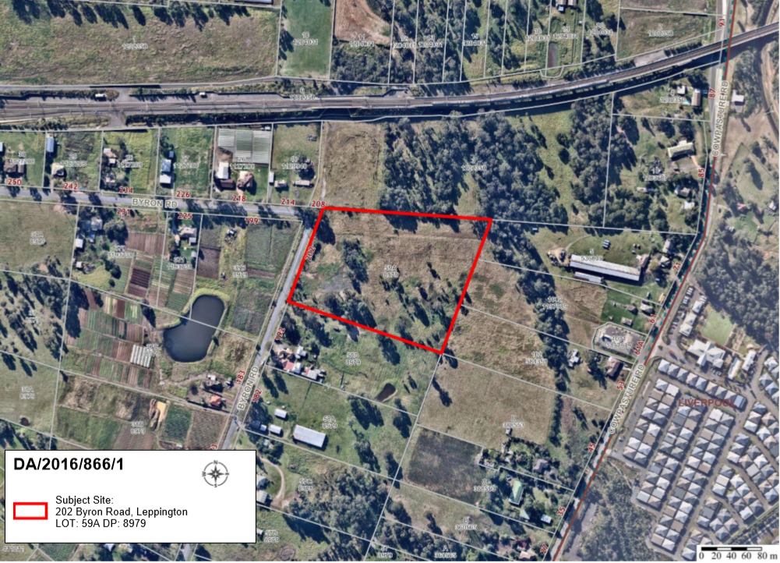

THE SITE

The site is commonly known as 202 Byron Road, Leppington and is legally described as Lot 59A DP 8979. The construction of the mixed use building is proposed on the subject site with drainage works to form a drainage swale to convey stormwater flows from the development towards Bonds Creek, proposed within 71 Cowpasture Road, Leppington to the north east of the site.

Batters and easements for support for road construction along adjoining properties to the north (208 Byron Road, Leppington) and to the south (192 Byron Road, Leppington) will be required.

The site is generally rectangular in shape with a frontage of approximately 136m to Byron Road, a maximum depth of approximately 229m and an overall area of approximately 3.6ha. The site has a cross fall of approximately 5m over 297m from its south western corner to its north eastern corner. The site is vacant except for some scattered vegetation across the site and a tributary of Bonds Creek along its eastern side.
The site is partially mapped as bush fire prone land, predominately within the north east corner of the site and is located within the Austral and Leppington North Precinct and the Leppington Major Centre of the South Western Growth Centre.

The surrounding area is characterised by undulating topography, scattered vegetation and a range of rural and rural residential land uses. The majority of the site is bio-certified, with the exception of a small portion of land at the north east corner of the site, which is mapped as existing native vegetation and native vegetation retention area.

Bonds Creek, Camden Valley Way and the developing Antegra retirement village lie to the east. To the south and west lie existing rural and rural residential properties that have been rezoned for residential and commercial development as part of the Leppington North Precinct. The Leppington line (railway), Bringelly Road and a piggery at 171 Bringelly Road (Bringelly Bacon Co.), lie to the north. Leppington Train Station is located approximately 650m to the north west.

ZONING PLAN

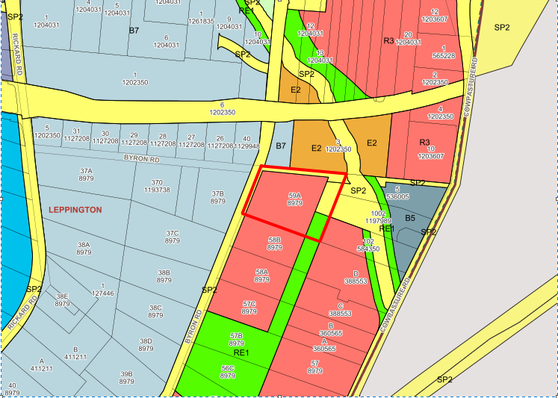

INDICATIVE LAYOUT PLAN (SCHEDULE 2 – LEPPINGTON MAJOR CENTRE)

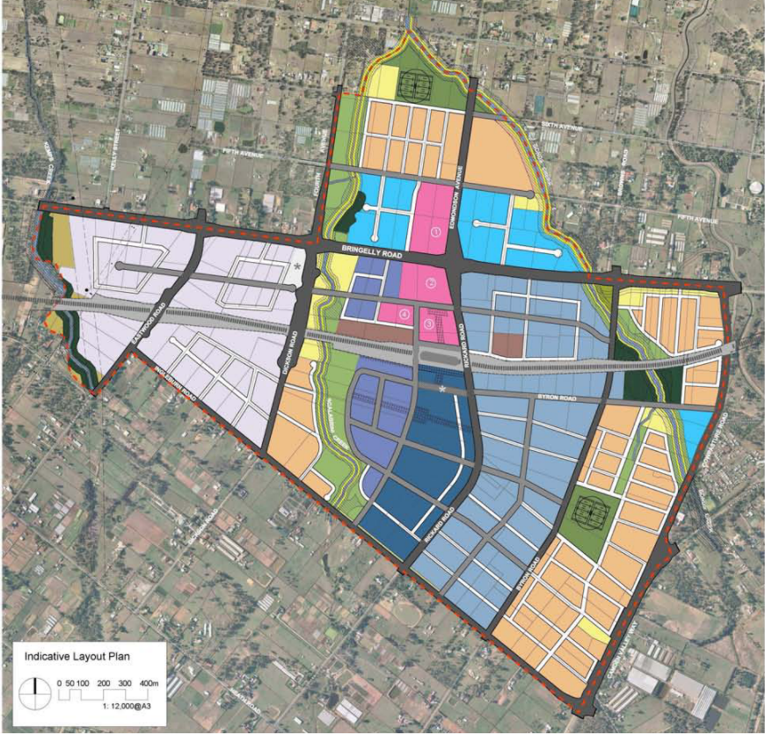
Site

THE PROPOSAL

DA/866/2016 seeks approval for tree removal, construction of a mixed use development of five (5) buildings comprising residential flat buildings and shop top housing for a total of 436 apartments, one (1) neighbourhood shop, basement car parking, road construction, subdivision and associated site works.

Specifically, the development involves:

• Bulk earthworks;

• Removal of (61) trees;

• Road construction consisting of a 25m wide town centre road, a 16.5m collector road and an 8m wide half wide local residential street;

• Torrens title subdivision to create two lots, one for residential development subject to this application (18,283m²) and one for future drainage purposes and passive open space (6203m²);
• Construction of a mixed use development consisting of five (5) buildings, containing 436 residential units and one neighbourhood shop, including 46 x 1 bedroom units, 331 x 2 bedroom units, 49 x 3 bedroom units and 10 x 4 bedroom units. Forty four (44) adaptable units are proposed;

The building will be constructed of masonry and glazing. Wall finishes will consist of painted concrete in various colours and finishes and powder coated aluminum in dark grey and bronze.

- Construction of two levels of basement parking providing 512 parking spaces for residents and 88 spaces for visitors, 30 spaces for motorbikes / scooters, and a designated carwash space. 184 bicycle spaces are provided throughout the development within secured areas upon the ground floor;

• Associated site works, including drainage and landscaping.

PANEL BRIEFING

Council staff last briefed the Panel on the DA on 4 March 2019. The following discussion provides an assessment of how the issues raised by the Panel at the briefing have been addressed:

- The extent to which the flooding reports supplied with the Application present a reliable basis to assess the proposal and necessary mitigation measures.

- The acceptability of the present design in that regard.

Council comments
Precinct planning mapping suggested that the R3 Medium Density Residential zoned portion of this site was not subject to flooding. However, updated flood modelling of the upstream catchment in a post development scenario, revealed that the extent of flooding was greater than previously mapped and would encroach upon the north east corner of the R3 medium density residential zoned portion of the site. Council Engineers are now satisfied with the submitted flood assessment and agree with the calculated flood planning level for the site (RL77.2m) and downstream tailwater levels, which dictate internal drainage design. The town centre road and the development have been designed to sit above the 1% AEP flood event, with the development now satisfactory in respect to flood planning requirements.

- Whether the proposed scale, height and density are compatible with the objectives of the R3 zone, available infrastructure, having regard to the likely impacts of the development on the surrounding area and its expected context. In that regard, while the SEPP only imposes a development standard for minimum density, that does not mean that a considered planning assessment would accept any density as appropriate and acceptable having regard to relevant matters.

Council comments
It is considered that the development is consistent with the objectives of the R3 zone by providing a range of 1, 2, 3 and 4 bedroom units, including several adaptable units within walkable proximity to Leppington Train Station. The mix of apartment types will contribute to housing diversity and will increase housing choice within Leppington by providing housing in a transitioning area with good access to the future emerging town centre and employment lands.

Whilst a minor height breach is proposed to two lift overruns, the central location of the lift overruns within the roof will not result in any perceptible visual impact from the public domain or neighbouring properties. Despite the height breach, no additional impact from overshadowing will occur to the public domain or communal open space areas, as the shadows will fall upon the roof area of the proposed buildings.

In respect to density, the development standard technically does not apply to residential flat development and relates only to principal and secondary dwelling development. The development does not result in adverse impacts in respect to overshadowing or loss of visual privacy upon adjoining properties, and is considered to be an appropriate built form response to the site attributes.

It is considered that the development is largely consistent with the Design Quality Principles and the Apartment Design Guide. The development provides a range of building heights, upper floor setbacks, varying façade design and horizontal and vertical architectural elements projecting from the main façade to provide articulation and visual interest. The development also accentuates the corners at the north east and north west along the town centre road, creating urban markers at the corners. Accordingly, the design is considered to be of a high standard and of architectural merit and desirable in establishing the Leppington Town Centre.

- Odour noting the nearby piggery.

Council comments
The site sits below the 4.5 OU (250 hours) contour. Accordingly, the development is not significantly impacted by nearby odour sources.

ASSESSMENT

Environmental Planning and Assessment Act 1979 - Section 4.15(1)

In determining a DA, the consent authority is to take into consideration such of the following matters as are of relevance to the development the subject of the DA:

(a)(i) the provisions of any environmental planning instrument

The environmental planning instruments that apply to the development are:

- State Environmental Planning Policy (State and Regional Development) 2011.
- State Environmental Planning Policy (Sydney Region Growth Centres) 2006.
- State Environmental Planning Policy No 55 – Remediation of Land.
- State Environmental Planning Policy No 65 – Design Quality of Residential Apartment Development.
- State Environmental Planning Policy (Building Sustainability Index: BASIX) 2004.
- State Environmental Planning Policy (Infrastructure) 2007.
- Sydney Regional Environmental Plan No 20 - Hawkesbury-Nepean River.
- Camden Growth Centre Precincts Development Control Plan.

State Environmental Planning Policy (State and Regional Development) 2011 (SRD SEPP)

The SRD SEPP identifies development that is State significant or regionally significant development.

The Panel is the consent authority for this DA as the CIV of the development is $141,666,455. This exceeds the CIV threshold of $30 million for Council to determine the DA pursuant to Schedule 7 of the SRD SEPP.

State Environmental Planning Policy (Sydney Region Growth Centres) 2006 (Growth SEPP)

The Growth SEPP aims to co-ordinate the release of land for residential, employment and other urban development in the North West Growth Centre, the South West Growth Centre and the Wilton Growth Area.

Site Zoning

The site is zoned SP2 Infrastructure along the site’s entire northern property boundary and western property boundary adjacent to Byron Road. Along the eastern property boundary, the site is partly zoned SP2 Infrastructure (for future drainage purposes) and RE1 Public Recreation. The majority of the site is zoned R3 Medium Density Residential.

Land Use Definitions

The development is defined as a “mixed use development” comprising “residential flat buildings” and an “neighbourhood shop” by the Growth SEPP.

Permissibility

The proposed residential flat buildings will be restricted to the part of the site zoned R3 Medium Density Residential. All of the development is permitted with consent in the zones in which it is proposed pursuant to the land use table in Appendix 9 of the Growth SEPP.

Planning Controls

An assessment table in which the development is considered against the Growth SEPP’s planning controls is provided as an attachment to this report.

Proposed Contravention

The applicant proposes a contravention to the height of buildings development standard that applies to the site (Clause 4.3). The development standard limits buildings to a maximum height of 21m above finished ground level. However, the development will have a maximum height of 21.25m above finished ground level. The contravention relates to two lift overruns; one atop building D (21.25m) and one atop building E (21.07m). The breaches are shown upon the height plan diagram within the architectural suite of plans.

Contravention Assessment

Pursuant to Appendix 9, Clause 4.6(3) of the Growth SEPP, the applicant has submitted a written request that seeks to justify the contravention of the development standard. In summary, the applicant’s written request provides the following justification for the contravention:

- Solar Access and Overshadowing. The shadow diagrams prepared by Rothelowman illustrate that the shadows generated by the proposed variations will fall on the proposed buildings and have no additional overshadowing impact on the public domain or communal open space areas. Despite the minor height contraventions the proposal will maintain a minimum of 2 hours sunlight to the future development and open space on neighbouring sites on the 21 June. In this regard, there is no adverse solar access of overshadowing resulting from the proposed variations.

- Visual Impact. The proposed variations exclusively relate to two lift overruns located central (setback from the building parapets) to the Building D and Building E envelopes. The site itself has four main road frontages bound by public domain elements including footpaths and the future public open space adjacent to Bonds Creek. When viewed from these key areas of the public domain, the 0.07m Building D variation and 0.25m Building E variations will be imperceptible. As the predominant building height and volume sits below the 21m height plane, the buildings will be read as a compliant built form. In this regard, there is no adverse visual impact resulting from the proposed variations.

- Flooding. The proposed ground floor levels have been raised by 0.4m to achieve flood compliance as detailed within the hydraulic Impact Assessment prepared by ADG dated August 2019. Specifically, the 76.8m AHD flood planning level originally adopted did not account for the ultimate flood level when the road crossing to the north east is considered. Considering the ultimate road crossing in place, the resultant flood planning level is 77.2m AHD (i.e. 1% AEP flood level of 76.7 + 500mm freeboard). Consequently, amending the design to meet flood level compliance resulted in two lift overruns protruding through the 21m height plane to a maximum of 0.25m or 1.2% above the height limit. The requirement for the lift overruns to marginally breach the maximum building height is therefore in response to the site-specific environmental constraints.

Buildings D and E have both been raised 0.4m to achieve flood compliance as detailed within the Hydraulic Impact Assessment prepared by ADG dated August 2019. Notwithstanding this, through skillful design, the variations to the building height have been isolated to two lift overruns with minimum variations of 0.07m and 0.25m which equates to an imperceptible 1.2% maximum variation. Maintaining this development standard in this instance would require Building D and E lift shafts to be reduced which would remove the top floor of these buildings which is a missed opportunity to deliver housing within the South West Growth Centre, which remains significantly undeveloped since the Leppington precinct rezoning over a decade ago.

- Fire Engineering. The Building Code of Australia was amended in 2019 to require all residential flat buildings to contain sprinkler protection. Previously, this requirement only applied to residential flat buildings above 25m. The impact of this change is that where previously a 3m floor to floor height was sufficient to achieve a 2.7m floor to floor ceiling height, this is no longer possible for buildings under 25m, and a 3.05m floor to floor is required.

The cumulative impact of all residential floors being 50mm higher is an extra 300mm in the 6 storey portions of the building, which results in the lift overrun serving the top floor of the building being 300mm higher and marginally exceeding the maximum building height in two locations.

In summary, the building has been designed to ensure that all habitable floor levels are below the maximum height limit. The change to the BCA, which wouldn’t have been anticipated during the formation of the development standards that apply to the site, is having a direct impact on the maximum height of the building. The proposed variation to the maximum height limit is directly related to the increase in floor to floor heights to achieve technical compliance with the BCA.

- Topography and Finished Ground Level. As demonstrated on the site survey, the existing ground levels vary across the site. The site slopes from south-west corner to north-east corner, resulting in a 4m cross fall. In addition, Council has instructed the applicant to raise the site where necessary to achieve appropriate road grades to accommodate stormwater requirements. Therefore, the finished site levels have been adjusted to allow the ground floor of the buildings to relate to the proposed roads levels in order to provide an appropriate relationship between the future built form and the public domain. In this regard, while the building will result in two minor height variations, based on the existing site survey levels, if taken from the post civil works finished ground level, all building elements will be under the 21m height plane. Importantly, this finished level is the level pedestrians will perceive the building mass following construction completion, as such it will be read as a maximum 21m form from the finished public domain.

A copy of the applicant’s written request is provided as an attachment to this report.

Pursuant to Appendix 9, Clause 4.6(4) of the Growth SEPP, Council staff are satisfied that:

- the applicant’s written request has adequately addressed the matters required to be demonstrated by Appendix 9, Clause 4.6(3) of the Growth SEPP, and

- the development will be in the public interest because it is consistent with the objectives of the particular standard and the objectives for development within the zones in which the development is proposed to be carried out.

The development standard contravention is supported for the following reasons:

- the development is consistent with the objectives of the development standard:

- to establish the maximum height of buildings

The Growth Centres SEPP establishes a 21m maximum building height and the proposal has been informed by this control. The proposal results in all buildings being under the 21m height limit, apart from two lift overruns which are a maximum of 0.25m or 1.2% above the 21m height limit, as such the proposal establishes a dominant 21m building height. All building parapets are compliant with the 21m maximum height. The lift overruns are located within the centre of Building D and Building E and therefore, when viewed from the public domain, the buildings will read as a compliant 21m form. The proposal is consistent with this objective.

- to minimize visual impact and protect the amenity of adjoining development and land in terms of solar access to buildings and open space.

As the building elements above the 21m height plane are two lift overruns located in the centre of Building D and Building E, they will not result in any perceptible visual impact from the public domain or neighbouring properties. Shadows cast will fall on the proposed buildings and have no additional overshadowing impact on the public domain or communal open space areas. The shadow diagrams prepared by Rothelowman illustrate that the proposed development will maintain minimum 2 hours sunlight to the future development and open space on neighbouring sites on the 21 June.

- to facilitate higher density development in and around commercial centres and major transport routes.

The site is within 700 metres of the train station and will form part of the eastern gateway to the Leppington Major Centre Precinct. The proposed height variations will allow the development to respond to the site-specific flood constraint, as well as maintain the upper levels of Buildings D and Building E, therefore allowing the development to continue to provide higher density housing in proximity to a rail station, which is commensurate with the transit oriented development principles envisaged for the area. Strict compliance with the development standard would require the removal of a storey of housing in order to comply with the development standard, which is contrary to the objective of promoting higher densities in a location well serviced by existing transport infrastructure.

- The development is consistent with the objectives for development within the zones in which the development is proposed to be carried out:

R3 Medium Density Residential

- To provide for the housing needs of the community within a medium density residential environment.

The development provides for a mix of 1, 2, 3 and 4 bedroom apartments, including 44 adaptable units. This contributes to housing diversity and will increase housing choice within Leppington by providing housing in a transitioning urban area with good access to an emerging commercial centre, employment lands and public transport.

- To provide a variety of housing types within a medium density residential environment.

The development proposes a mix of dwelling typologies consisting of 1, 2, 3 and 4 bedroom apartments within a medium density residential environment to provide for the housing needs of the community.

- To enable other land uses that provide facilities or services to meet the day to day needs of residents

The proposed development proposes an 86.5m² neighbourhood shop to enable a small retail premises to exist and provide convenience goods such as foodstuffs, personal care products, newspapers and the like to provide for day to day needs of people who live or work in the local area.

- To support the wellbeing community by enabling educational, recreational, community, religious and other activities where compatible with the amenity of a medium density residential environment.

This objective is not relevant to the development, as it does not propose these activities to occur.

- The contravention relates to two lift overruns that are located centrally within the roof space of Buildings D and E. The location and height of the lift overruns does not result in any perceptible visual impacts and will not result in additional overshadowing impact upon the public domain or communal open space areas.

- The buildings will still read as a compliant 21m built form, noting that the breaches are unable to be viewed from the public domain.

- The proposed development will not have any significant impacts on adjoining properties as there will be no additional effect on solar access to the proposed development, adjoining development or upon the public domain.

It is noted that the Panel may assume the concurrence of the Secretary.

Consequently, it is recommended that the Panel support this proposed contravention to the Growth SEPP.

State Environmental Planning Policy No 55 - Remediation of Land (SEPP 55)

The SEPP requires the consent authority to be satisfied that the site is suitable for its intended use (in terms of contamination) prior to granting consent.

Clause 7 of SEPP 55 requires the consent authority to consider if the site is contaminated. If the site is contaminated, the consent authority must be satisfied that it is suitable in its contaminated state for the development. If the site requires remediation, the consent authority must be satisfied that it will be remediated before the land is used for the development. Furthermore, the consent authority must consider a preliminary contamination investigation in certain circumstances.

Hibbs & Associates Pty Ltd conducted an asbestos surface clearance and soil investigation of 202 Byron Road, Leppington, which included sixteen (16) samples throughout the site. At the completion of the inspection, no visible or accessible asbestos fragments or suspect asbestos containing debris was observed over the suspected former building locations or stockpile locations. This assessment found the site to be suitable for the development from a contamination perspective. Council staff have reviewed the assessment, agree with its findings and are satisfied that the site is suitable for the development.

Following assessment of the detailed contamination, a large quantity of asbestos was illegally dumped upon the site in February 2019. As this material sits on top of the soil and not buried within the soil, conditions of consent have been prepared requiring that the dumped material is tested, removed from site and any remaining soil validated to ensure that the material has been appropriately removed.

A standard contingency condition is recommended that requires any contamination found during construction to be managed in accordance with Council's Management of Contaminated Lands policy.

State Environmental Planning Policy No 65 – Quality Design of Residential Apartment Development (SEPP)

SEPP No. 65 aims to improve the design quality of residential apartment development and provides an assessment framework, the Apartment Design Guide for assessing ‘good design’. The SEPP requires consideration of any Development Application for residential accommodation meeting the application criteria of the SEPP against the nine (9) design quality principles, including the advice obtained from a design review panel and the Apartment Design Guide (ADG). A copy of the assessment of the proposed development against the design criteria and objectives of the ADG is provided as an attachment to this report, with assessment of the application revealing that the development is largely consistent with the ADG and the design quality principles.

The proposed development has been assessed against the SEPP’s design quality principles:

Principle 1: Context and Neighbourhood Character

The entire area is undergoing a significant transition from rural/rural residential to an urban character. The proposed development provides an acceptable built form for the future urban character of the area and will make a positive contribution to that future context. This has been done by achieving general compliance with the relevant planning controls that will also guide the development of that future character and context.

Principle 2: Built Form and Scale

The development provides a range of building heights, upper floor setbacks, varying façade design and horizontal and vertical architectural elements projecting from the main façade to provide articulation and visual interest. The development also accentuates the corners at the north east and north west along the town centre road, creating urban markers at the corners. Accordingly, the design is considered to be of a high standard and of architectural merit and desirable in establishing the Leppington Town Centre.

Principle 3: Density

The proposed development will achieve a density of 163.9 dwellings per hectare, which consists of 1, 2, 3 and 4 bedroom apartments. The proposed density does not result in adverse impacts in respect to overshadowing or loss of visual privacy upon adjoining properties, nor is the development considered to be an unacceptable built form. Higher densities are considered appropriate in this location given its location in the Town Centre with good access to an emerging commercial centre, employment lands and public transport.

Principle 4: Sustainability

The proposed development will incorporate a number of sustainability features including solar access and natural ventilation consistent with the ADG objectives, attractive landscaped and usable communal open spaces, both at ground level and upper levels and compliance with BASIX requirements.

Significant bicycle storage exists within the development to promote alternative and sustainable transport options to and from and beyond the site.

Principle 5: Landscape

The proposed landscaping will achieve deep soil zones consistent with the ADG and provide additional planting and planter beds in ground and upper level communal open spaces. The communal open spaces include seating, shelters, bbq areas and a combination of soft and paved surfaces, providing recreation and social interaction opportunities whilst being overlooked by the proposed apartments for safety and security.

Principle 6: Amenity

The proposed apartments’ layouts and designs are generally compliant with the ADG design criteria and will provide reasonable amenity for future residents. A choice of open space opportunities has been provided through ground and upper level communal open spaces in the form of turfed areas, landscaped gardens and semi-covered terraces with seating.

Principle 7: Safety

The proposed apartment private open space areas and communal open space areas are well defined and legible, defining which areas are private and for communal use. The proposed buildings provide active frontages to all public roads, maximising passive surveillance opportunities. Controlled access will be provided to the proposed buildings via intercoms and key card access. Secure resident parking areas will be provided in the proposed basement. A condition is recommended that requires a number of additional security features recommended by the Camden Local Area Command to be incorporated into the proposed development. These will include CCTV cameras, building security, lighting, vegetation management, security signage and graffiti removal.

Principle 8: Housing Diversity and Social Interaction

The proposed development will provide a variety of apartment types and sizes, including forty-four adaptable units. The development will create ground and upper floor communal open space areas to allow for a variety of active and passive recreational uses to be enjoyed by the residents of the development.

Principle 9: Aesthetics

The development provides a range of building heights, upper floor setbacks, varying façade design and horizontal and vertical architectural elements projecting from the main façade to provide articulation and visual interest. The development also accentuates the corners at the north east and north west along the town centre road, creating urban markers at the corners. A variety of durable, high quality materials are proposed.

State Environmental Planning Policy (Building Sustainability Index: BASIX) 2004

The applicant has submitted a valid BASIX certificate in support of the DA that demonstrates that water, thermal comfort and energy requirements have been achieved.

State Environmental Planning Policy (Infrastructure) 2007 (ISEPP)

The ISEPP aims to facilitate the effective delivery of infrastructure across the State.

Clause 85 – Sydney Trains

The DA was referred to Sydney Trains for comment pursuant to Clause 85 of the ISEPP. Sydney Trains raised no objection to the development, subject to the imposition of a condition requesting that an acoustic assessment be submitted demonstrating how the proposed development will comply with the Department of Planning’s document titled “Development Near Rail Corridors and Busy Roads – Interim Guidelines”. The condition is provided within the attached set of recommended conditions.

Clause 104 – Traffic Generating Development

The DA was referred to RMS for comment pursuant to Clause 104 of the ISEPP as, pursuant to Schedule 3 of the ISEPP, the development is classed as traffic generating development.

RMS reviewed the application and generally raised no objection to the development, however raised three matters for Council consideration.

- Any intersection design for the Town Centre Road / Byron Road intersection should not preclude the possible future need for traffic signals. Council as the roads authority will need to ensure that adequate corridor footprint has been allowed to cater for implementation of a suitable traffic control signal layout should the warrants be met.

- Council is advised that the vehicular access / egress to the Town Centre Road is considered to be too close to the Town Centre Road / Byron Road intersection, considering the potential outcome of (1) above. It is recommended that the proponent relocate the access / egress driveway away from the intersection as was recommended in the Roads and Maritime Services correspondence of 12 March and April 2018.

- It is recommended that a median be included within the access road and wide enough to accommodate a third lane when required in the future. Turning paths for dual left or right should be investigated by the developer so that a kerb radius meets future requirements.

Council Comments
The precinct planning and recent traffic modelling for the Town Centre have not identified that the intersection of Byron Road and the Town Centre Road is to be controlled with a signalized intersection. The precinct planning and concept intersection plans have identified that this intersection will be controlled by a roundabout, with the development providing sufficient building offsets and land for future acquisition to accommodate construction of a roundabout in the future.

The typical cross section for the town centre road as per figure 4-6 of Schedule 2 – Leppington Major Centres of Camden Growth Centre Precincts Development Control Plan does not envisage a central median. The future 25m road reserve will provide for a 7m carriageway (3.5m lane width), and 2.2m wide cycle lane and 2.3m dedicated parking bay upon both sides of the road, with 4.5m road verges.

The location of the northern basement entrance to the development from the Town Centre Road is dictated by flooding and associated flooding requirements, which require that the pedestrian and vehicular access to the development to be located above the 1% AEP level plus 500mm freeboard. As the Town Centre Road falls to the east towards future drainage reserve land, the basement entrance is located at a point along the Town Centre Road whereby the levels of the basement ramp can achieve flood immunity. The floor planning level incorporating a 500mm freeboard is RL 77.20m. The crest of the northern basement entry connecting to the Town Centre Road is set at RL 77.56m above the flood planning level.

Consideration of the location of the basement entrance in proximity to the intersection of Byron Road / Town Centre Road has been made by Council Traffic Engineers, who are satisfied with the location. Consideration of extending island splinters from the future roundabout or a narrow median may be considered during detailed design of the roundabout.

Sydney Regional Environmental Plan No 20 - Hawkesbury-Nepean River (SREP 20)

SREP 20 aims to protect the environment of the Hawkesbury-Nepean River system by ensuring that the impacts of future land uses are considered in a regional context.

The development is consistent with the aim of SREP 20 and all of its planning controls. There will be no detrimental impacts upon the Hawkesbury-Nepean River system as a result of the development. Appropriate erosion, sediment and water pollution control measures have been proposed as part of the development.

(a)(ii) the provisions of any proposed instrument that is or has been the subject of public consultation under this Act and that has been notified to the consent authority (unless the Secretary has notified the consent authority that the making of the proposed instrument has been deferred indefinitely or has not been approved)

Draft Environment State Environmental Planning Policy (Draft Environment SEPP)

The development is consistent with the Draft Environment SEPP in that there will be no detrimental impacts upon the Hawkesbury-Nepean River system as a result of it.

(a)(iii) the provisions of any development control plan

The development control plans that apply to the development are:

- Camden Development Control Plan 2011; and
- Camden Growth Centre Precincts Development Control Plan.

Camden Growth Centre Precincts Development Control Plan

Planning Controls

An assessment table in which the development is considered against Camden Growth Centre Precincts Development Control Plan is provided as an attachment to this report.

Proposed Variation

The applicant proposes variations to primary and secondary setbacks (corner lots) contrary to the development controls of Table 4-10 Clause 4.3.5(3) of Camden Growth Centre Precincts Development Control Plan.

The development controls specify that:

- Front setback of at least 6m with 1.5m balcony articulation encroachments permitted for the first three storeys for 50% of the façade length; and

- Corner lots require a secondary street setback of at least 6m.

The application proposes variations to the balcony encroachments upon Byron Road (front setback) to continue upon the 4th, 5th and 6th storeys of the development at 4.5m and for balcony encroachments to exist upon the secondary setback to Building C along the northern town centre road at 4.5m, balcony encroachments to Buildings C and E upon the eastern collector road at 4.5m for upper levels and balcony encroachments to Buildings D and E upon the southern local residential street at 4.5m for all levels for the first 6 storeys.

Applicants Justification

The applicant has provided the following reasons in support of the proposed variations:

- To avoid a repetitive and overly-consistent street wall, modulation in the façade is employed to provide play to the street edge. The skirting façade sometimes breaks up into the setback zone to create a false façade, behind which are located the terraces to the setback, maisonette apartments.

Variation Assessment

The proposed variations to both the front setback and secondary setback are considered reasonable and desirable to achieve and set the character for acceptable built form in the Town Centre. Variation to these setbacks assists in modulating and providing horizontal and vertical articulation to the facades, which in absence, would otherwise result in a uniform setback across multiple facades and excessive street wall height, with no human scale as per the development controls. The development also accentuates the corners at the north east and north west along the town centre road, creating urban markers at the corners. Accordingly, the proposed setbacks reinforce the design strategy of the development, which is considered to be of a high standard and of architectural merit.

Consequently, it is recommended that the Panel support this proposed variation to the Camden Growth Centre Precincts Development Control Plan.

(a)(iiia) the provisions of any planning agreement that has been entered into under section 7.4, or any draft planning agreement that a developer has offered to enter into under section 7.4

No relevant planning agreement or draft planning agreement exists or has been proposed as part of this DA.

(a)(iv) the regulations (to the extent that they prescribe matters for the purposes of this paragraph)

The Environmental Planning and Assessment Regulation 2000 prescribes several matters that are addressed in the conditions attached to this report.

(b) the likely impacts of the development, including environmental impacts on both the natural and built environments, and social and economic impacts in the locality

As demonstrated by the assessment, the development is unlikely to have any unreasonable adverse impacts on either the natural or built environments, or the social and economic conditions in the locality.

Ultimate works – Byron Road

Whilst assessment of the application has demonstrated that no unreasonable adverse impacts are generated by the development, it is considered prudent to identify and distinguish the interim works and ultimate works that the development relies upon.

The development proposes the construction of the northern town centre road, eastern collector road and southern local residential street, however, interim road connections are provided at the western ends of the Town Centre Road and local residential street. These works are interim as the upgrade of Byron Road in its ultimate sub arterial configuration is yet to be fully designed, with construction dates for this upgrade yet to be confirmed.

In respect to the Byron Road upgrade and roundabout construction, Council currently has an agreement with INSW to deliver concept design, detailed design, draft business case and final business case for Byron Road by 30th September 2022 funded by NSW treasury for $7.8 million. This time frame may require an extension given the Leppington Town Centre Master Plan Review work being undertaken by Council’s Strategic Planning team and any subsequent adoption of a new Indicative Layout Plan (ILP).

A final business case will put forward Council’s position on funding required to proceed with the land acquisition and construction. Commencement towards construction is dependent on Council’s final business case being successfully assured (accepted) by the INSW Assurance process. As such, the construction timeframe can only be determined once Council is successful in receiving further grants in future funding rounds for land acquisition and construction work.

(c) the suitability of the site for the development

As demonstrated by the above assessment, the site is considered to be suitable for the development.

(d) any submissions made in accordance with this Act or the regulations

The DA was publicly exhibited for a period of 30 days in accordance with Camden Development Control Plan 2011. The exhibition period was from 10 August to 8 September 2016. Two submissions were received (one objecting to the development and one raising a matter for consideration).

Following the submission of amended plans and additional information the DA was publicly re-exhibited for a period of 30 days in accordance with Camden Development Control Plan 2011. The re-exhibition period was from 21 February to 22 March 2018. Two submissions were received.

The issues raised in the submissions relate to:

• Open space treatment;
• Stormwater / stormwater retention;
• On-site carparking;
• Flooding;
• Impact on health and wellbeing of local residents;
• Environmental impact and sustainability;
• Existing traffic, noise and parking problems already on Byron Road, Leppington
• Hardship from acquisition
• Provision for access across the proposed rear boundary open space linkage.

The following discussion addresses the issues raised in the submissions.

- Open space treatment

Officer comment:

The embellishment of the proposed park has now been withdrawn through amended plans. The future embellishment of the adjoining RE1 zoned land will be delivered by Council following acquisition of this land.

- Stormwater / stormwater retention

Officer comment:

In the absence of downstream works to form drainage reserves and regional basins, a temporary combined on-site stormwater detention and biofiltration basin is proposed to be constructed to the east of the development sites to accommodate drainage flows and provide water quality treatment. Further civil works include constructing a drainage swale and obtaining a drainage easement over 71 Cowpasture Road to the north east of the site to convey drainage flows from the temporary stormwater detention / biofiltration basin to Bonds Creek.

- On-site carparking

Officer comment:

Assessment of carparking reveals that the development satisfies the visitor and residential carparking rates as per the Camden Growth Centre Precincts Development Control Plan.

- Flooding

Officer comment:

Precinct planning mapping suggested that the R3 Medium Density Residential zoned portion of this site was not subject to flooding. However, updated flood modelling of the upstream catchment reveals that the extent of flooding was greater than previously mapped and would encroach upon the north east corner of the R3 medium density residential zoned portion of the site. The town centre road and the development have been designed to sit above the 1% AEP flood event.

Council’s Engineers are satisfied that the works proposed in the interim case will not have adverse impacts in respect to localized flooding upon adjoining properties.

- Impact on health and wellbeing of local residents. The development will negatively impact them in the following ways; lower their living standards and quality of life, dramatic lifestyle change, increase noise pollution, increase air pollution, increase traffic, increase waste generation, increase road deterioration, pressure on existing government services, increase in social & economic problems, pressure on public transport, a downgrade of image.

Officer comment:

This site has been identified for residential redevelopment, with the majority of Leppington rezoned to accommodate residential development. The site is located within the South Western Growth Centre and is within the Austral and Leppington North Precinct and the Leppington Major Centre of the South Western Growth Centre.

It is acknowledged that the existing character of the area still largely remains rural and the issues raised by the objector stem from the major change this development will bring to the area. However, the area of Leppington has been identified through precinct planning and subsequently rezoned to accommodate such a permissible development. The area is in a state of transition from rural to residential. As demonstrated by the assessment, the development is considered unlikely to have any unreasonable adverse impacts on either the natural or built environments, or the social and economic conditions in the locality.

- Environmental impact and sustainability. The development will see destruction of fauna and destruction of flora.

Officer comment:

Tree removal is proposed as part of the application and has been considered by Council’s Urban Tree and Landscape Officer. Proposed tree removal is shown upon drawing C102 – Existing features layout plan, revision G, prepared by ADG. With the exception of trees located in areas of mapped existing native vegetation and native vegetation retention at the north east corner of the site, the site is bio-certified and tree removal can be granted with consent.

In respect to the loss of fauna, the site is not identified as containing or supporting populations of fauna required to be protected.

- Existing traffic, noise and parking problems already on Byron Road, Leppington

Officer comment:

The proposed development will not exaggerate existing noise, traffic and parking problems within Byron Road, as the development is fully compliant with DCP requirements in respect to residential and visitor carparking. It is acknowledged that overflow parking from commuters at Leppington Train Station extends down Byron Road and Rickard Road, however this situation is due to demand and insufficient carparking capacity at Leppington Train Station.

Construction impacts will be managed on site, with a construction management plan a requirement of development consent, which will specify construction vehicle routes, number of trucks / vehicles, hours of operation, access arrangements and traffic control.

As discussed earlier in this report, the upgrade of Byron Road will be undertaken by Council. Council currently has an agreement with INSW to deliver concept design, detailed design, draft business case and a final business case for Byron Road by 30th September 2022 funded by NSW treasury for $7.8 million.

- Hardship from acquisition

Officer comment:

The issue of future acquisition of the objectors properties and potential financial hardship is not related to the current development application. Precinct planning and the gazettal of acquisition mapping under State Environmental Planning Policy (Sydney Region Growth Centres), has identified areas for future acquisition to accommodate future open space, roads (classified and local roads), drainage and for community facilities. Land acquired through acquisition is not obtained for free, with land acquired at market rates.

- It is considered desirable, for enhanced connectivity, that provision be made for access across the proposed rear boundary open space linkage.

Officer comment:

A submission, rather than an objection, was received seeking for the development to accommodate access across the open space land to the east. It appears that the request for access across the open space land has been made to allow the adjoining eastern neighbor the ability to develop their land and enable a legal road connection to Byron Road in the absence of other ILP roads and access denial to Cowpasture Road in the future. As per the ILP, the adjoining eastern site is reliant on the development of other sites to deliver local roads to enable legal road access to facilitate future residential development. The ILP does not intend to sever the RE1 and SP2 land to the east of the proposed collector road. In addition, alternative means of access are available to the adjoining site subject to the ILP. As such, provision for access across the RE1 zoned land is not considered to be required by the applicant to provide in this instance.

(e) the public interest

The public interest is served through the detailed assessment of this DA under the Environmental Planning and Assessment Act 1979, the Environmental Planning and Assessment Regulation 2000, environmental planning instruments, development control plans and policies. Based on the above assessment, the development is consistent with the public interest.

EXTERNAL REFERRALS

The external referrals undertaken for this DA are summarised in the following table:

External Referral | Response
Department of Primary Industries - Water | No objection and General Terms of Approval for works requiring a controlled activity approval under the Water Management Act, 2000 granted.
NSW Rural Fire Service. | No objection and a Bush Fire Safety Authority granted.
Sydney Trains | No objection and recommended conditions provided.
RMS | Generally, no objections. Matters of consideration raised, including recommended conditions.
Police (Camden Local Area Command) | No objection and safer by design recommendations provided.

Conditions that require compliance with the General Terms of Approval from the Department of Primary Industries – Water; the Bush Fire Safety Authority; and external referral recommendations are included in the recommended conditions.

FINANCIAL IMPLICATIONS

This matter has no direct financial implications for Council.

CONCLUSION

The DA has been assessed in accordance with Section 4.15(1) of the Environmental Planning and Assessment Act 1979 and all relevant instruments, plans and policies. Based on the assessment, it is recommended that the DA be granted deferred commencement consent subject to the terms and conditions attached to this report.

RECOMMENDED
That the Panel:

- support the justification in the applicant’s written request lodged pursuant to Appendix 9, Clause 4.6(3) of State Environmental Planning Policy (Sydney Region Growth Centres) 2006 to the contravention of the height of buildings development standard, and

- approve DA/2016/866 for tree removal, construction of a mixed use development consisting of five (5) buildings comprising residential flat buildings and shop top housing for a total of 436 apartments, one (1) neighbourhood shop, basement car parking, road construction, subdivision and associated site works at 202 Byron Road, Leppington subject to the deferred commencement conditions attached to this report.

